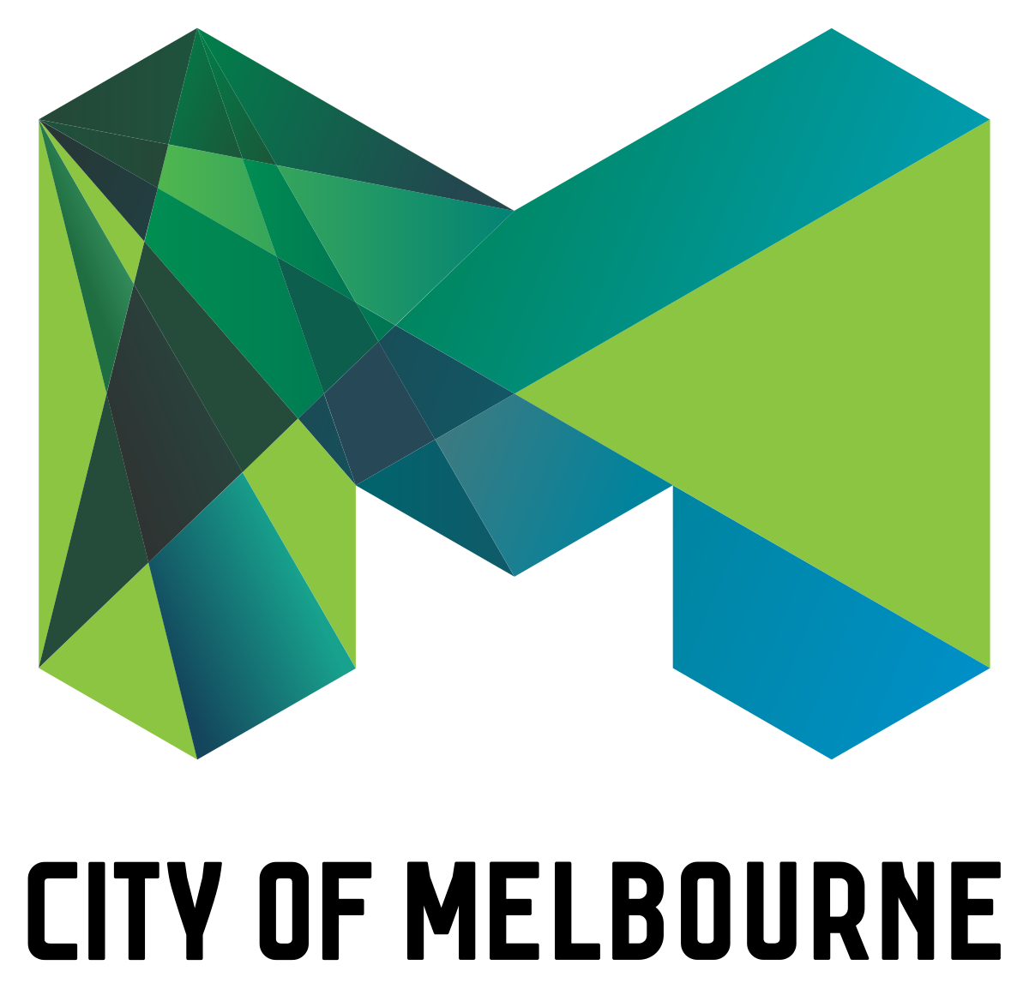

**HOUSING MARKET ANALYSIS**

Submitted by

Sugumaran BALASUBRAMANIYAN

This report aims to provide insights and key findings derived from the dataset, including variables such as address, type of real estate, suburb, method of selling, rooms, price, real estate agent, date of sale, distance from CBD, and more.

**Dataset Description:**

Address: The address of the property.

Type: The type of real estate, such as house, unit, townhouse, etc.

Suburb: The suburb where the property is located.

Method: The method of selling the property, such as property sold, sold prior, passed in, withdrawn, etc.

Rooms: The number of rooms in the property.

Price: The price of the property in dollars.

SellerG: The real estate agent or seller of the property.

Date: The date when the property was sold.

Distance: The distance of the property from the central business district (CBD).

Regionname: The general region where the property is located, such as West, North West, North, North East, etc.

Propertycount: The number of properties in the suburb.

Bedroom2: The number of bedrooms (scraped from a different source).

Bathroom: The number of bathrooms in the property.

Car: The number of car spots or parking spaces available.

Landsize: The size of the land associated with the property.

BuildingArea: The size of the building or property.

CouncilArea: The governing council responsible for the area where the property is located.

These variables provide information about the properties, their attributes, and the selling details, which can be useful for various real estate analyses, such as price prediction, market trends, location preferences, and more.

**Insights:**

Number of Records: The dataset contains 13,580 records or entries.

Average Land Size: The average land size across the dataset is 558.4.

Average Price: The average price of the properties in the dataset is 1.1 million dollars.

Average Distance from CBD: The average distance of the properties from the central business district (CBD) is 10.1 units

Oldest Property: The oldest property in the dataset was built on 1196.

**Top Real Estate Agents:** The top real estate agents based on their frequency in the dataset are Nelson, Jelis, Barry, Ray, and Marshall. These agents appear most frequently as sellers or associated with the properties in the dataset.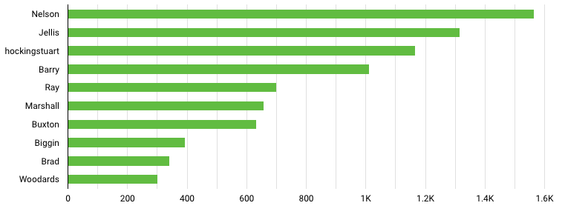

**Property Distribution in Suburbs:**

**a. Reservoir:** The dataset contains 359 properties located in Reservoir. Reservoir is a suburb known for its diverse housing options and convenient location in the northern part of Melbourne. The relatively high number of properties in Reservoir suggests a significant level of market activity in the area.

**b. Richmond:** Richmond is another suburb with a strong presence in the dataset, with 360 properties listed. Richmond is known for its vibrant culture, proximity to the CBD, and a wide range of housing options. The large number of properties in Richmond indicates a thriving real estate market in this sought-after suburb.

**c. Bentleigh East:** The dataset includes 249 properties in Bentleigh East. Bentleigh East is a suburban area known for its family-friendly environment and proximity to amenities. The relatively high number of properties suggests a stable and active real estate market in Bentleigh East.

**d. Preston:** Preston is represented by 239 properties in the dataset. Located in Melbourne's northern suburbs, Preston offers a mix of residential and commercial areas. The presence of a considerable number of properties in Preston indicates a steady demand for real estate in this area.

**e. Brunswick:** Brunswick is another suburb included in the dataset, with 222 properties listed. Brunswick is known for its vibrant community, diverse cultural scene, and convenient access to the CBD. The presence of a significant number of properties in Brunswick suggests a lively real estate market in this popular suburb.

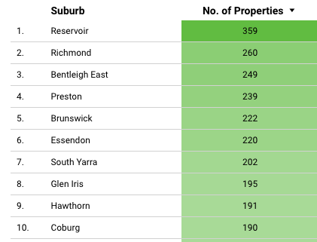

**Highly priced regions:**

The dataset reveals that the **South Eastern Metropolitan** region has the highest-priced properties, with the highest-priced property listed at **9 million** dollars. This region is renowned for its upscale and prestigious neighbourhoods, offering luxurious and high-end properties. Similarly, the Southern Metropolitan region follows closely behind with the highest-priced property listed at 8 million dollars, indicating its status as an affluent and sought-after area.

The **Northern Metropolitan region** showcases high-priced properties as well, with the highest-priced property listed at **4.5 million** dollars. It signifies the desirability and exclusivity of this region. The **Eastern Metropolitan region**, with the highest-priced property listed at **4 million** dollars, also exhibits upscale properties that attract discerning buyers. Lastly, the **Western Metropolitan region** showcases a slightly lower range of high-priced properties, with the highest-priced property listed at **3.9 million** dollars. Overall, these regions stand out for their luxury properties, reflecting their esteemed status within the metropolitan area.

**Percentage of Properties in Each Region:**

a. South Metropolitan: The dataset indicates that **34.6%** of the properties are located in the South Metropolitan region. This region encompasses suburbs located to the south of the central business district (CBD). The relatively high percentage suggests that there is a significant presence of properties in this region, indicating a potentially active real estate market.

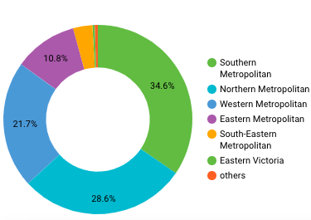

b. Northern Metropolitan: Approximately **28.6%** of the properties in the dataset are located in the Northern Metropolitan region. This region comprises suburbs to the north of the CBD. The percentage suggests a considerable number of properties in this region, highlighting its popularity among homebuyers and investors.

c. Western Metropolitan: The dataset reveals that **21.7%** of the properties are situated in the Western Metropolitan region. This region covers suburbs to the west of the CBD. The percentage implies a substantial presence of properties in the western region, indicating potential opportunities for real estate activities.

d. Eastern Metropolitan: The dataset indicates that **10.8%** of the properties are located in the Eastern Metropolitan region. This region includes suburbs situated to the east of the CBD. The relatively lower percentage suggests a comparatively smaller concentration of properties in this region compared to others.

These percentages indicate the distribution of properties across different regions. It shows that the South Metropolitan region has the highest percentage of properties, followed by the Northern Metropolitan, Western Metropolitan, and Eastern Metropolitan regions.

The analysis of the real estate dataset also reveals the Council Areas in Melbourne with the **highest counts of properties sold**. Topping the list is Darebin, with **1,300** properties sold, followed closely by Moreland and Maribyrnong, both with **1,100** properties sold. Yarra ranks fourth with **1,000** properties sold, while Moonee Valley, Glen Eira, Boroondara, and Stonnington complete the list with 900, 850, 720, and 700 properties sold, respectively. This ranking provides valuable insights into the sales activity and market dynamics within each Council Area.

The higher number of properties sold in these areas suggests a strong demand for real estate and potential market growth. It also highlights the popularity of these Council Areas among homebuyers and investors. The information can be useful for individuals and organizations looking to invest or operate in the real estate market, providing guidance on areas with higher sales activity and market potential.

**Dataset Source:** <https://www.kaggle.com/datasets/dansbecker/melbourne-housing-snapshot>

**Looker Studio Dashboard:** <https://lookerstudio.google.com/reporting/dc393d0b-ba9c-4536-9bcf-06e239762db3>